Fossil fuel:
Oil:
Demand/Consumption
World demand for oil is projected to increase 37% over 2006 levels by 2030 (118 million barrels per day (18.8×106 m3/d) from 86 million barrels (13.7×106 m3)), due in large part to increases in demand from the transportation sector.
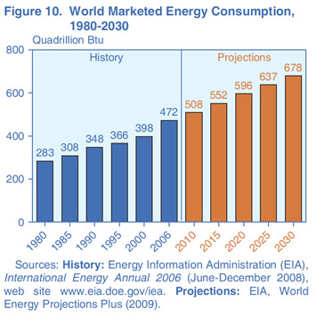
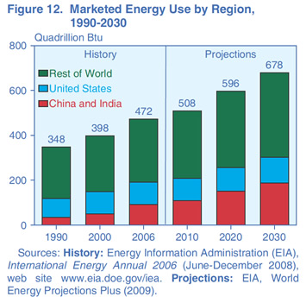

Supply/Production
According to a January 2007 International Energy Agency report, global supply (which includes biofuels, non-crude sources of petroleum, and use of strategic oil reserves, in addition to crude production) averaged 85.24 million barrels per day (13.552×106 m3/d) in 2006, up 0.76 million barrels per day (121×103 m3/d) (0.9%), from 2005.
The IEA's March 2008 Oil Market report showed global supply to be 87.5 million barrels per day (13.91×106 m3/d), compared to 84.3 million barrels per day (13.40×106 m3/d) in July 2007, a 3.8% increase on that interval. The great bulk of the increase came in the non-OPEC sector, which now makes up 65% of global production.

Oil peak
Optimistic estimations of peak production forecast the global decline will begin by 2020 or later, and assume major investments in alternatives will occur before a crisis, without requiring major changes in the lifestyle of heavily oil-consuming nations.
Pessimistic predictions of future oil production operate on the thesis that either the peak has already occurred,[5][6][7] oil production is on the cusp of the peak, or that it will occur shortly.

Depletion
The American Petroleum Institute estimated in 1999 the world's oil supply would be depleted between 2062 and 2094, assuming total world oil reserves at between 1.4 and 2 trillion barrels and consumption at 80 million barrels per day.[4] In 2004, total world reserves were estimated to be 1.25 trillion barrels and daily consumption was about 85 million barrels, shifting the estimated oil depletion year to 2057.[1] The United States Energy Information Administration predicts world consumption of oil will increase to 98.3 million barrels per day in 2015 and 118 million barrels per day in 2030.

Nature Gas
Supply and Demand
The rate of discovery has fallen below the rate of consumption in 1980.[4] The gap has been widening ever since. Declining gas discovery rates foreshadow future production decline rates because gas production can only follow gas discoveries.
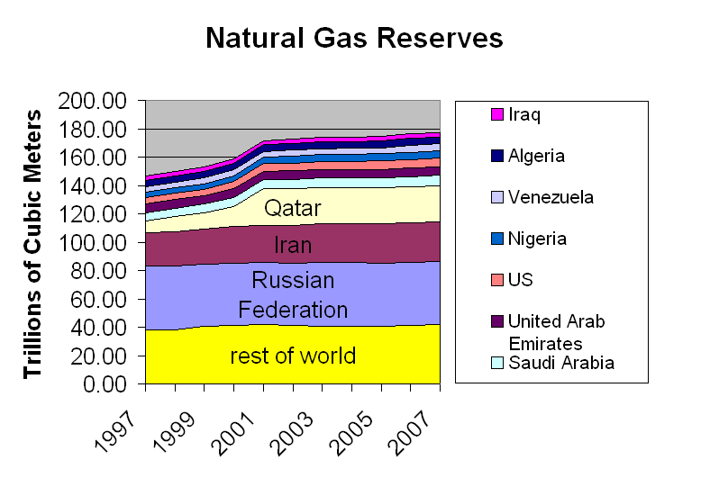

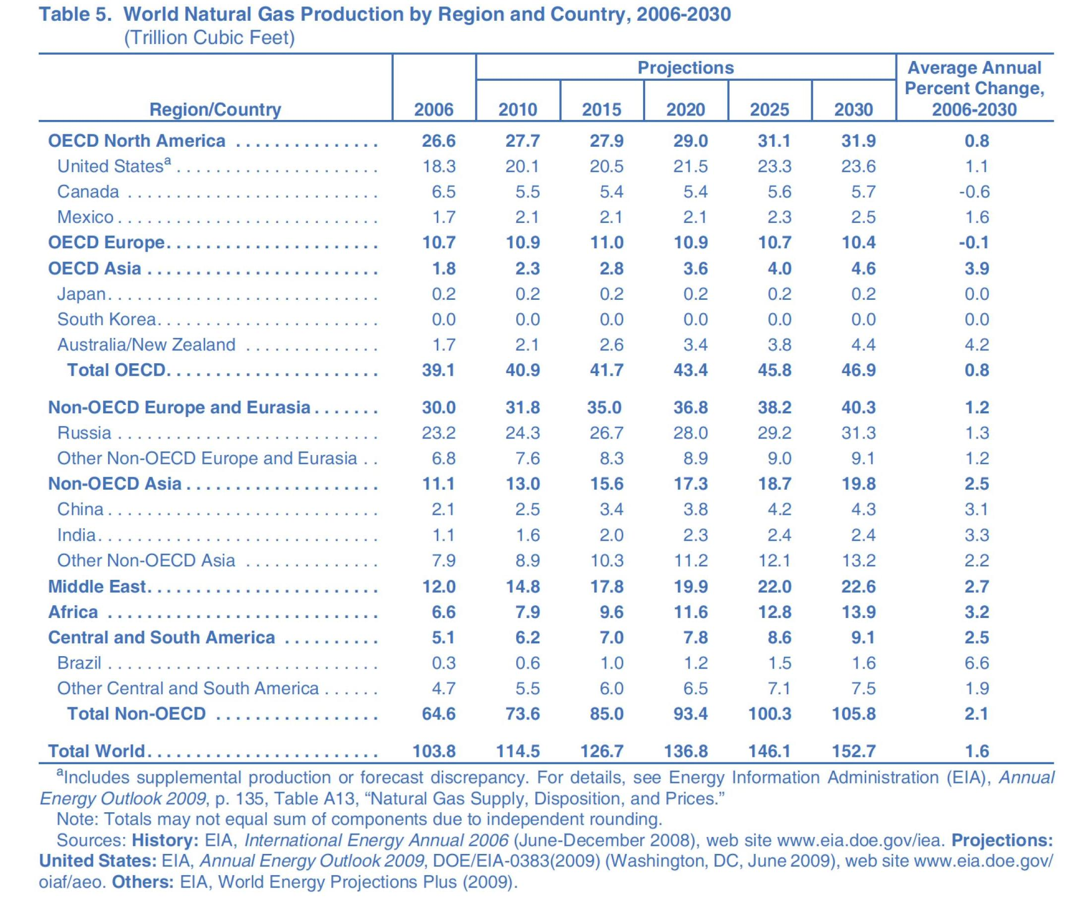
The most important energy agencies in the world are forecasting increases in natural gas demand in the next 20 years.[3] The largest increments in future gas demand are expected to come from developing countries.
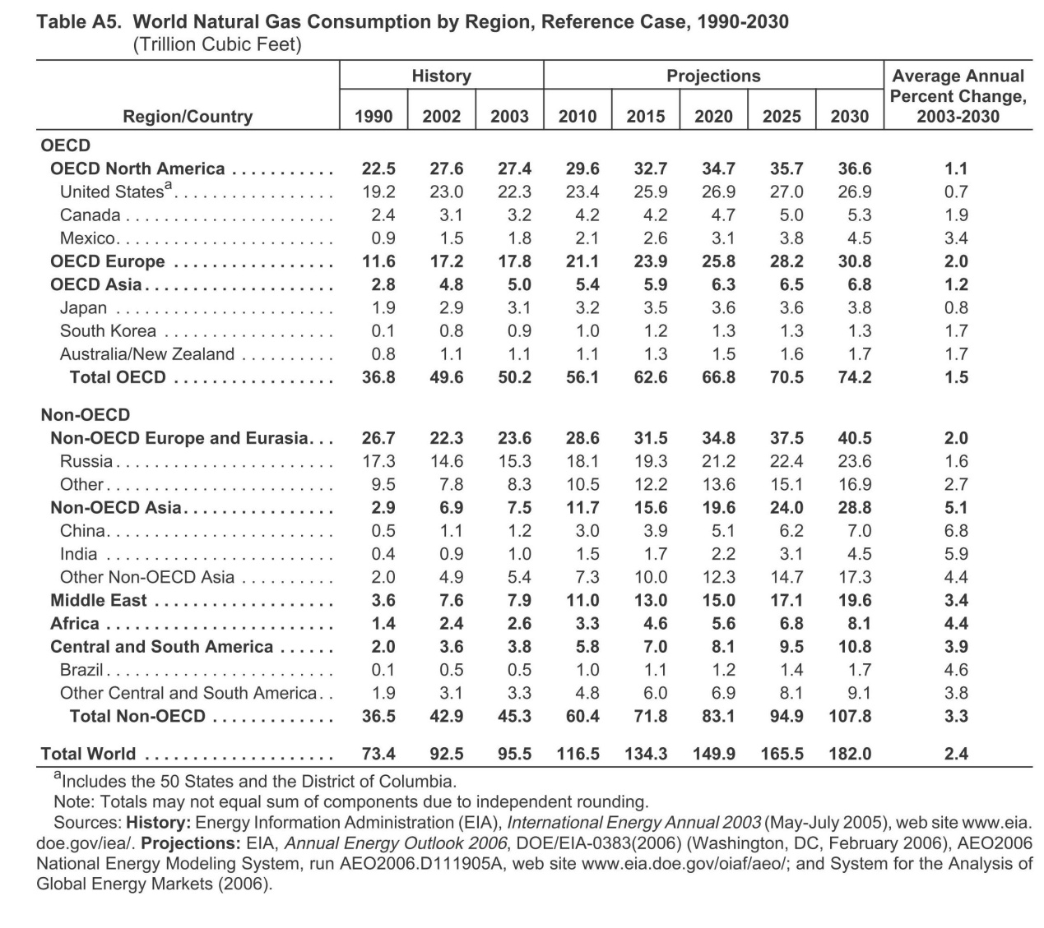
Peak Gas
In 2002, R.W. Bentley (p.189) predicted a global "decline in conventional gas production from about 2020."[29]

The US Energy Information Administration predicts that world gas production will continue to increase through 2030.

Depletion
According to the Energy Information Agency[1], the world in 2005 had about 60 years[2] of natural gas left. But if one compares proven North American reserves versus North American consumption, one gets only 11 years

Coal
Supply and Demand:
Total recoverable reserves of coal around the world are estimated at 929 billion tons—reflecting a current reserves-to-production ratio of 137.

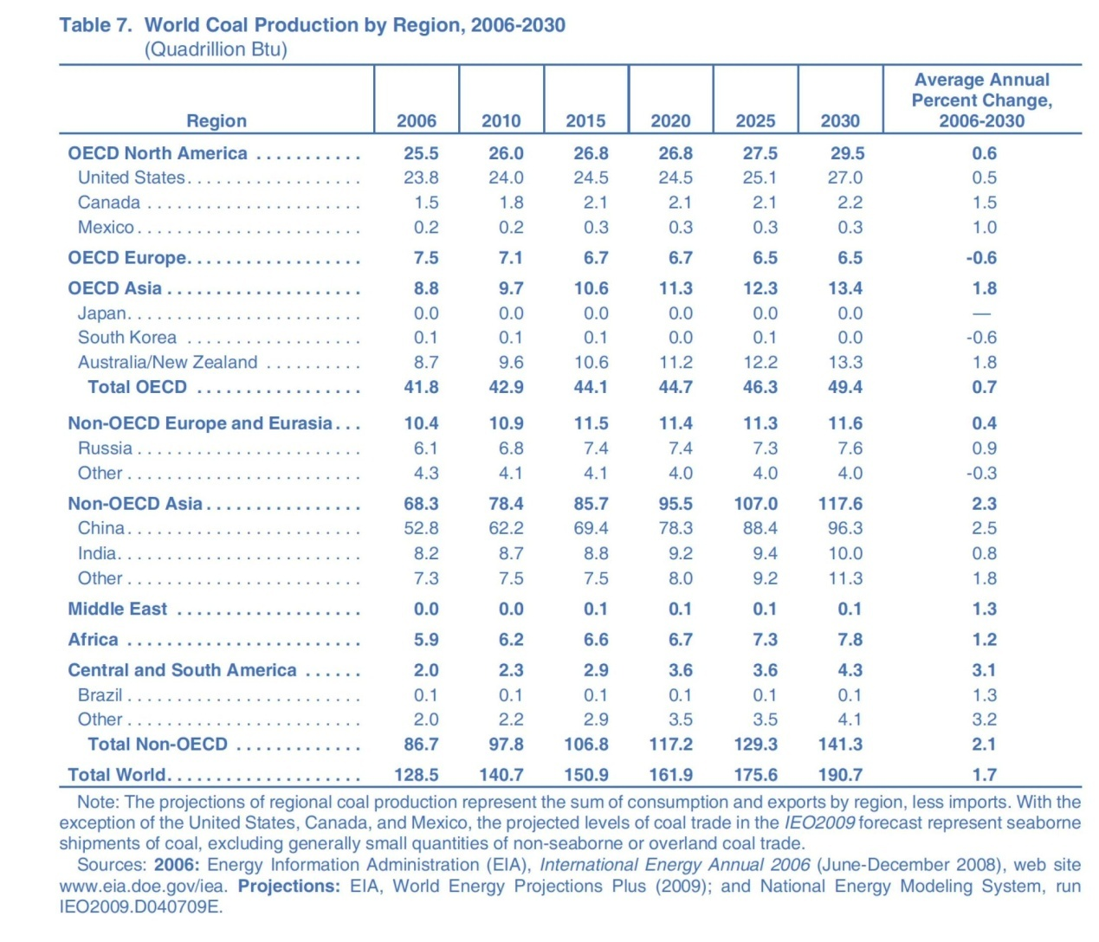

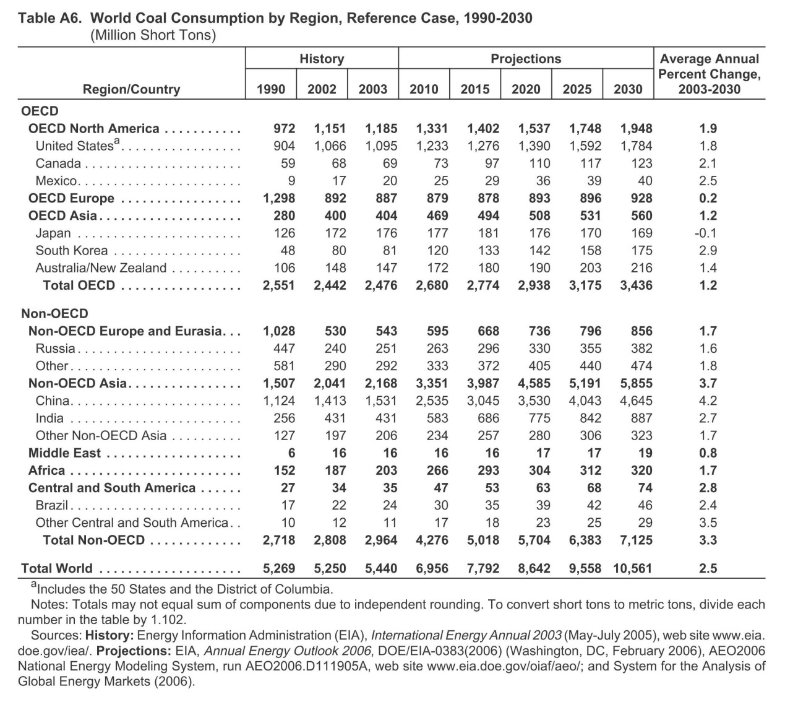

Peak Coal
Coal: Resources and Future Production[14], published on April 5 2007 by the Energy Watch Group (EWG), which reports to the German Parliament, found that global coal production could peak in as few as 15 years.

Depletion
Assuming the current rate of consumption and that there are still an estimated 909 billion tonnes of proven coal reserves worldwide, there is enough coal to last at least 155 years.

Water
Fresh water is a renewable resource, yet the world's supply of clean, fresh water is steadily decreasing. The world has an estimated 326 quintillion gallons of water but 97 percent of it is salty.[8] Nearly 70% of that fresh water is frozen in the icecaps of Antarctica and Greenland. Most of the remainder is present as soil moisture or lies in deep underground aquifers as groundwater not accessible to human use. Less than 1% of the world's fresh water or 0.007% of all water on earth is accessible for direct human use. This is the water found in lakes, rivers, reservoirs and those underground sources that are shallow enough to be tapped at an affordable cost. Only this minuscule amount is regularly renewed by rain and snowfall, and is therefore available on a sustainable basis.

The amount of available freshwater supply is decreasing because of climate change, which has caused receding glaciers, reduced stream and river flow, and shrinking lakes. Many aquifers have been over-pumped and are not recharging quickly. Although the total fresh water supply is not used up, much has become polluted, salted, unsuitable or otherwise unavailable for drinking, industry and agriculture.

Water demand already exceeds supply in many parts of the world, and as the world population continues to rise at an unprecedented rate, many more areas are expected to experience this imbalance in the near future.

Agriculture represents 70% of freshwater use worldwide.

Generally speaking the more developed countries of North America, Europe and Russia will not see a serious threat to water supply by the year 2025, not only because of their relative wealth, but more importantly their populations will be better aligned with available water resources. North Africa, the Middle East, South Africa and northern China will face very severe water shortages due to physical scarcity and a condition of overpopulation relative to their carrying capacity with respect to water supply. Most of South America, Sub-Saharan Africa, Southern China and India will face water supply shortages by 2025; for these latter regions the causes of scarcity will be economic constraints to developing safe drinking water, as well as excessive population growth.

1.6 billion people have gained access to a safe water source since 1990. [2] The proportion of people in developing countries with access to safe water is calculated to have improved from 30 percent in 1970[17] to 71 percent in 1990, 79 percent in 2000 and 84 percent in 2004. This trend is projected to continue.

According to projections, the number of people at risk from
increasing water stress will be between 0.4 billion and 1.7 billion
by the 2020s, between 1.0 billion and 2.0 billion by the 2050s
and between 1.1 billion and 3.2 billion by the 2080s.

Increasing water scarcity combined with increased food demand
and/or water use for irrigation as a result of higher temperatures
are likely to lead to enhanced water reuse. Areas with low
sanitation coverage might be found to be practising (as a new
activity or to a greater degree) uncontrolled water reuse (reuse
that is performed using polluted water or even wastewater).

an increase in morbidity and mortality rates from
water-borne diseases for both more humid and drier scenarios
is expected, owing to an insufficient supply of potable water
(Kovats et al., 2005; Ebi et al., 2006), and the greater presence
of pathogens conveyed by high water flows during extreme
precipitation. Increased precipitation may also result in higher
turbidity and nutrient loadings in water. The water utility of
New York City has identified heavy precipitation events as
one of its major climate-change-related concerns because they can raise turbidity levels in some of the city’s main reservoirs
by up to 100 times the legal limit for source quality at the
utility’s intakes, requiring substantial additional treatment and
monitoring costs (Miller and Yates, 2006).

Forest

Production and consumption of key wood products
and wood energy are expected to rise from the present to
2030, largely following historical trends. The most dramatic
change will be the rapid increase in the use of wood as
a source of energy, particularly in Europe, as a result of
policies promoting greater use of renewable energy. The
highest growth rates will continue to be in Asia, which will
be the major producer and consumer of wood-based panels
and paper and paperboard (although per capita consumption
will remain higher in Europe and North America).
Industrial roundwood production in Asia will be far short of
consumption, increasing the dependence on imports.
The potential for large-scale commercial production of
cellulosic biofuel will have unprecedented impacts on the
forest sector. Increasing transport costs will also influence
the demand for wood products. These factors and others,
including changes in exchange rates, will influence the
competitiveness of the forest sector and affect production and
consumption of most forest products.
Industrial roundwood will be increasingly likely to come
from planted forests in the future. This continuing shift
presents interesting opportunities and challenges for forest
management.

It has been estimated that about half of the earth's mature tropical forests — between 7.5 million and 8 million km2 (2.9 million to 3 million sq mi) of the original 15 million to 16 million km2 (5.8 million to 6.2 million sq mi) that until 1947 covered the planet[74] — have now been cleared.[75][76] Some scientists have predicted that unless significant measures (such as seeking out and protecting old growth forests that have not been disturbed)[74] are taken on a worldwide basis, by 2030 there will only be ten percent remaining,[72][75] with another ten percent in a degraded condition.[72] 80% will have been lost, and with them hundreds of thousands of irreplaceable species.

A 2005 report by the United Nations Food and Agriculture Organization (FAO) estimates that although the earth's total forest area continues to decrease at about 13 million hectares per year, the global rate of deforestation has recently been slowing.[88][89] Still others claim that rainforests are being destroyed at an ever-quickening pace.

Food
In the long term, prices are expected to stabilize. Farmers will grow more grain for both fuel and food and eventually bring prices down. Already this is happening with wheat, with more crops to be planted in the United States, Canada and Europe in 2009. However, the Food and Agriculture Organization projects that consumers still face at least until 2018 more expensive food. It is rare that the spikes are hitting all major foods in most countries at once.

A variety of factors have combined to raise food prices to the highest levels since the 1970s (in real terms), with serious implications for food security among poor populations around the world. One of the most frequently mentioned contributing factors is the rapid recent growth in the use of agricultural commodities – including some food crops – for the production of biofuels.
FAO’s 2008 report on the State of Food and Agriculture ﬁnds that while biofuels will offset only a modest share of fossil energy use over the next decade, they will have much bigger impacts on agriculture and food security. The emergence of biofuels as a new and signiﬁcant source of demand for some agricultural commodities - including maize, sugar, oilseeds and palm oil – contributes to higher prices for agricultural commodities in general, and for the resources used to produce them.

Worldwide around 852 million people are chronically hungry due to extreme poverty, while up to 2 billion people lack food security intermittently due to varying degrees of poverty (source: FAO, 2003). As of late 2007, increased farming for use in biofuels,[4] world oil prices at more than $100 a barrel,[5] global population growth,[6] climate change,[7] loss of agricultural land to residential and industrial development,[8][9] and growing consumer demand in China and India[10] have pushed up the price of grain.[11][12] Food riots have recently taken place in many countries across the world.

The demand for food is expected to continue to grow as a result both of population growth and rising incomes. Demand for cereals (for food and animal feed) is projected to reach some 3 billion tonnes by 2050. Annual cereal production will have to grow by almost a billion tonnes (2.1 billion tonnes today), and meat production by over 200 million tonnes to reach a total of 470 million tonnes in 2050, 72 percent of which will be consumed in developing countries, up from the 58 percent today.

The production of biofuels could also increase the demand for agricultural commodities, depending on energy prices and government policies.

